Epsom & Ewell
19
v
Godalming Town
Tuesday, 12th February 2019 – 7.45 p.m.
Good evening and welcome to the players, supporters and officials of Godalming Town who are making their second visit of the season; this time for a League Cup last 16 encounter.

We have met twice already in the League and both were tight battles that came down in our favour; 3-2 here back in December when Scott Murphy’s winning goal was nearly missed by the officials due to the ball hitting the stanchion just inside the post and coming back out, and then in January when we edged through 3-1 at Wey Court in a match that was very even for an hour before a strong finish gave us the points. The winners of this tie face a challenging trip to Abbey Rangers in the Quarter-Final.

We were last at High Road just over three weeks ago on Saturday 19th January when we started well against Bagshot before losing our way, only to then produce a stunning five goal burst in the final twenty minutes to win 7-1. We then visited Godalming Town seven days later and picked up three more points with a 3-1 win. It was a fairly even match until the hour mark when we responded well to conceding an equaliser and were well in charge by the end.

We then had our next Saturday home match with Farnham Town postponed due to the snow before we visited the Orchard last Tuesday for a League Division One Cup Quarter-Final against Bedfont & Feltham and produced a dominant performance to win 2-1, although we did require a late penalty save from Conor Young to avoid the need for what would have been an undeserved period of extra time. Our Semi-Final opponents are currently unknown, but the full draw so far is contained later in the programme along with all the usual features.

Please note that the League match against Sheerwater that was postponed on 22nd December is now to be played on Tuesday 19th March, while our rearranged match at home to Farnham Town will now take place on Saturday 27th April. They are two very big matches if we can keep our good form up, which should be advised is now just one defeat in seventeen matches.

We also have many players and a few matches available for sponsorship, so don’t be shy, just speak with a Committee member for details. You know who and where we are!

Finally, we must of course advise that if the scores are level here after 90 minutes, then extra time would be played, and if still level then penalties would follow.

Enjoy the game!

Rich

You can follow us on Facebook: www.facebook.com/epsomandewellfc
Twitter: @EEFCOfficial Instagram at: www.instagram.com/epsomandewellfc
and Youtube at: www.youtube.com/channel/UCtLrpS0x5OaYUACRT34_zng

Cover photos by Gemma Jarman

- Reisse Griffin’s header draws us level at Cove on 5th January in a match we would win 2-1.
- A debut goal for Billy Carney as he heads our fourth goal of seven against Bagshot.
- Ben Chick also scored his first goals in that same match. Here is his second and our sixth.

Cherry Red Records Combined Counties League
Division One Table 2018/19
inc Saturday 9th February 2019 | P | W | D | L | F | A | Pts | GD | H | A

Bedfont & Feltham | 23 | 16 | 5 | 2 | 78 | 26 | 53 | +52 | 4-4 | 13/4
Frimley Green | 24 | 16 | 5 | 3 | 48 | 27 | 53 | +21 | 3-0 | 23/2
Sheerwater | 24 | 16 | 4 | 4 | 63 | 32 | 52 | +31 | 2-3 | 19/3
Epsom & Ewell | 24 | 15 | 3 | 6 | 61 | 37 | 48 | +24 | X | X
Farnham Town | 21 | 13 | 4 | 4 | 46 | 19 | 43 | +27 | 27/4 | 1-4
Tooting Bec | 22 | 12 | 5 | 5 | 51 | 28 | 41 | +23 | 3-1 | 30/3
Ash United | 25 | 12 | 5 | 8 | 64 | 52 | 41 | +12 | 1-1 | 2-1
Dorking Wanderers Res | 27 | 11 | 4 | 12 | 55 | 60 | 37 | -5 | 3-0 | 3-5
Sandhurst Town | 21 | 11 | 3 | 7 | 33 | 35 | 36 | -2 | 20/4 | 2-0
British Airways | 24 | 9 | 4 | 11 | 50 | 59 | 31 | -9 | 16/2 | 2-3
Chessington & Hook Utd | 22 | 8 | 5 | 9 | 40 | 43 | 29 | -3 | 1-2 | 4-1
Bagshot | 27 | 8 | 4 | 15 | 35 | 78 | 28 | -43 | 7-1 | 3-0
Godalming Town | 24 | 8 | 3 | 13 | 37 | 56 | 27 | -19 | 3-2 | 3-1
FC Deportivo Galicia | 23 | 6 | 3 | 14 | 39 | 45 | 21 | -6 | 12/3 | 3-0
Eversley & California | 22 | 5 | 2 | 15 | 39 | 55 | 17 | -16 | 1-0 | 1-2
Cove | 24 | 4 | 3 | 17 | 30 | 53 | 15 | -23 | 3-2 | 2-1
Fleet Spurs | 24 | 5 | 0 | 19 | 41 | 73 | 15 | -32 | 6/4 | 3-2
Kensington Borough | 23 | 3 | 6 | 14 | 27 | 59 | 15 | -32 | 1-1 | 9/3

AC London (removed) | 15 | 9 | 2 | 4 | 36 | 25 | 29 | +11 | - | 6-0

Lucky Day? – 12th February
Played 10 - Won 4 Drawn 3 Lost 3 - For 23 Against 12 - PPG 1.50 - Average
Our Club record against Godalming Town
Played 5 - Won 4 Drawn 0 Lost 1 - For 10 Against 8 - PPG 2.40 - Fantastic
Our Largest wins and losses against Godalming Town
30th January 2019 - W 3-1 - Combined Counties League (A)
21st November 2017 - L 0-3 - Combined Counties League (H)
Godalming Town’s Last Visit
1st December 2018 - Won 3-2 - Combined Counties League

Recent Results and Fixtures
Combined Counties League – Saturday 2nd February 2019
Bedfont & Feltham | p-p | Kensington Borough
Chessington & Hook United | p-p | Cove
Epsom & Ewell | p-p | Farnham Town
Eversley & California | p-p | Bagshot
FC Deportivo Galicia | 2-3 | Godalming Town
Fleet Spurs | p-p | Tooting Bec
Sandhurst Town | p-p | British Airways
Sheerwater | p-p | Ash United
Combined Counties Division One League Cup QF – Tuesday 5th February 2019
Bedfont & Feltham | 1-2 | Epsom & Ewell
Surrey Premier Cup QF – Tuesday 5th February 2019
Ash United | 1-3 | Frimley Green
Combined Counties League – Tuesday 5th February 2019
Fleet Spurs | 2-1 | Cove
Tooting Bec | p-p | British Airways
Combined Counties League – Saturday 9th February 2019
Ash United | 4-0 | Dorking Wanderers Reserves
Bagshot | 2-1 | Chessington & Hook United
British Airways | 1-4 | Bedfont & Feltham
Cove | 1-1 | Kensington Borough
Farnham Town | p-p | Sheerwater
Fleet Spurs | 3-4 | FC Deportivo Galicia
Godalming Town | 2-1 | Eversley & California
Combined Counties League Cup Third Round – Tuesday 12th February 2019
Epsom & Ewell | V | Godalming Town
Combined Counties League – Tuesday 12th February 2019
Chessington & Hook United | V | Farnham Town
Surrey Premier Cup QF – Saturday 16th February 2019
Nottsborough | V | Sheerwater
Combined Counties League – Saturday 16th February 2019
Bedfont & Feltham | V | Tooting Bec
Dorking Wanderers Reserves | V | Cove
Epsom & Ewell | V | British Airways
Eversley & California | V | FC Deportivo Galicia
Frimley Green | V | Godalming Town
Kensington Borough | V | Ash United
Sandhurst Town | V | Chessington & Hook United
Surrey Premier Cup QF – Wednesday 20th February 2019
Met Police Academy U23s | V | Epsom & Ewell

From behind the goal
Epsom & Ewell 7-1 Bagshot
Combined Counties League - Division One - Saturday 19th January 2019

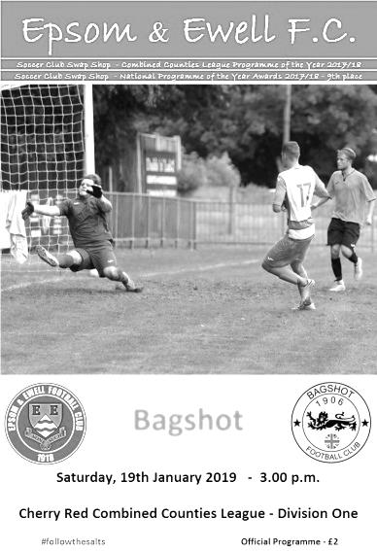
Late five goal blitz shatters Bagshot resistance

Just three weeks ago I wrote that we were due a day where we would take our chances. We might have had to wait a while in this match before it eventually happened but to score five goals in the final eighteen minute plus injury time was worth waiting for.

Our visitors were missing a few of their regulars, which left them limited on their bench and probably contributed to their late demise too, but we were missing Reisse Griffin and although Jamie Watts had completed his suspension, he was unavailable also. In addition the previously ever-present Lloyd Connelly was still struggling with an injury picked up the week before against Ash United and he spent the match on the bench. Luke Elgar and Ryan Sullivan both returned to the starting eleven while Billy Carney made his first start with Ben Chick returning to the bench, although he would be well involved later on.

We got off to a flying start with the players no doubt well aware where we went wrong the previous Saturday and took the lead in the 7th minute when Louis Chin was brought down 30 yards out. Rob Hendry delivered a curling set piece and Elgar was there to get on the end of it, guiding the ball past Adrian Giles in the Bagshot goal from the edge of the six yard box.

We nearly had another just two minutes later when Liam Roberts got through on the left. His cut back beat the defender who then brought him down in the box, but the referee wasn't convinced and then booked our man for complaining. It looked harsh, although having spoken to the referee afterwards, he felt that Roberts had made a meal of it and that was why it wasn't given. Looking back at the video I can see why he made that decision now, although I still think there was definitely enough for a penalty!

A Bagshot player received a similarly harsh yellow card for complaining after he also appeared to be fouled and we went 2-0 up in the 17th minute. This time Elgar fed Hendry with a 40 yard clearance that dropped over a defender and our in-form striker ran through and finished clinically into the bottom corner from twelve yards.

Louis Chin made an important block on the half hour but the addition of their Manager Phil Ruggles as a substitute made the contest more even and the visitors started to threaten. We had a warning in the 39th minute when Kai Parton-Edey struck a loose ball straight at Conor Young. However, we didn't heed the warning and within seconds a ball in from the right was met at the far post by Josh Ogunseye and he knocked the ball past the exposed Young in the 40th minute to bring them back into the match.

We nearly made it 3-1 in injury time when Roberts got through on the left but was brought down on the edge of the area, but again no foul was given. Carney drove hard and low from the edge of the box but Giles was able to gather the ball at the second attempt with Hendry incoming. We were good value for the lead at the half but warning signs were also present.

In fact, we started off the second half a little wobbly and the chances we created resulted in efforts well off target from Hendry and Roberts. However, we should have extended the lead in the 63rd minute when Chin sent over a pinpoint cross from the right but Carney's header from close range was straight at Giles. Chick replaced Roberts and nearly scored with his first touch as Bennett sent a deep ball to the far post but his contact actually sent the ball back across the six yard box where Hendry then hit the foot of the post with his header. Elliott Thompson followed that with a clever run but fired just over from the edge of the box.

The visitors still threatened on occasions and fired a long range free kick that was deflected for a corner but we cleared the danger and a five goal blitz soon followed; starting in the 72nd minute when Bennett cut in from the right and found Sullivan with a low pass who then found Chick on the left and he cut inside his defender and finished easily. Two minutes later it was 4-1 as Chick crossed from the left for Carney to head the ball into the roof of the net from close range.

Young made a good low save from Lekan Osideko before we responded with a long ball that the Bagshot defence had trouble with. Hendry nodded the ball onto Chick whose shot was tipped over the bar by Giles. In the 86th minute though we had another opportunity when Hendry was clumsily bundled over in the box. Bennett spoilt his 100% record from the spot a minute later as Giles guessed the right way, but the ball came back out and Bennett knocked in the loose ball. Two minutes later a smart pass from Thompson put Chick through and from twenty yards he realised that Giles was off his line and curled the ball around him and into the vacant net.

We completed the scoring in the 95th minute when substitute Sam Morgan set Bennett off down the right and his low ball in was swept past Giles by Hendry from close range to make it 7-1 which it must be admitted was a little harsh on Bagshot who contributed plenty to this match and were in my opinion a better side than the Ash team we'd played seven days earlier until that final period.

Ultimately the difference between our team and the clubs higher up is that they are slightly more consistent than us and this was highlighted for me on Saturday by a superb first 30 minutes, followed by a very wobbly period either side of half time and then our strong finish, which is indicative of our season so far really. We can beat anyone and even be quite devastating at times as Bagshot found out this weekend and it must be pointed out that they had held Champions elect Bedfont & Feltham to a draw just seven days previously. However, this result could all be for nothing if we then throw in a weak performance when we visit Godalming next weekend. Let's hope we can keep this form up, which it should be pointed out now represents just one loss in fifteen matches.

Epsom and Ewell: Conor Young, Louis Chin, Luke Elgar, Ryan Sullivan, Adam Heagney, Elliott Thompson, Bobby Bennett, Scott Murphy (c), Rob Hendry, Billy Carney,
Liam Roberts

Subs: Ben Chick for Roberts (60), Roy Gayle for Sullivan (77),
Sam Morgan for Carney (79)

From behind the goal
Godalming Town 1-3 Epsom & Ewell
Combined Counties League - Division One - Saturday 26th January 2019

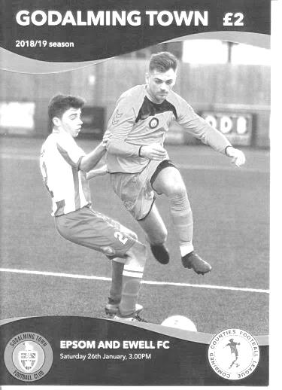
Salts find a way to win at Wey Court

Whisper it quietly but our boys are putting together a bit of a late run! Our latest league win at Godalming Town gives us a record of eight matches unbeaten with just one defeat in 16 matches and despite a mid-match wobble we came through and finished strongly in the end to maintain our record.

Godalming came into this match on a run of three heavy defeats and had brought in some new players, one of whom, Reece Weekes had an impressive outing. We made just two changes from last week's heavy win over Bagshot with Ben Chick coming in for the injured Liam Roberts and Lloyd Connelly coming back into the starting eleven for Adam Heagney who was unwell and as a result his ever present run, the last one for our club this season, came to an end.

We started well with Billy Carney putting Bobby Bennett through on goal in the second minute and he struck his shot well but Jordan Knight made a good save with his legs and the danger was cleared. Two minutes later Carney then set up Rob Hendry for a shot on the turn which was on target but was at a good height and Knight made an easy save.

The play then became fairly even for a while with the hosts even shading the possession, but it counted for nothing in the 18th minute as Carney's flick on put Hendry through and he struck the ball low across Knight into the bottom corner from twelve yards to put us ahead. Then Joseph Lewis for the home side found himself in the book for a foul which would have consequences for the defender later on.

Godalming were still contributing plenty to this match and their impressive Captain Jack Howard was just wide with a low shot and on the half hour they probably should have equalised when Donte-Lodge-Francis managed to escape Connelly for about the only time in the match. Through on goal in a central position he ran in on Conor Young, but our man stood up well and made the save with his left foot, with the subsequent corner coming to nothing.

Unfortunately Elliott Thompson picked up an injury around the half hour mark and was replaced by Roy Gayle. We continued to look dangerous when going forward though and Chick's curling delivery from the right was just beyond the incoming Hendry. Carney then made another dangerous run before setting up Hendry whose low shot was deflected across goal and just wide of the post by a covering defender. It could have gone anywhere!

Two minutes from half time Luke Elgar made a fine run. He set up Bennett who had switched to the left wing and he ran in before pulling the ball back where Elgar had continued his run. His shot was blocked but that didn't stop our man from winning the ball again and indeed

once more but the ball was cleared away in the end by a grateful defender. Then moments before the players went off Bennett sent a stinging shot at goal that Knight could only parry but the loose ball was cleared and we went in just the one goal ahead.

As we found out against Ash not long ago a one goal lead can prove vulnerable. We started the second half slowly with Weekes sending two shots just above Young's goal. He then sent a ball across the face of our goal but fortunately there was no one there to finish it off. The pressure was building though and they equalised in unusual circumstances in the 55th minute. We had looked fairly solid defensively to this point, but a long ball pumped over the top left Oliver Stevens in acres of space and Young was the only one who could stop him. The ball bounced up but it was outside the area so our keeper couldn't use his hands and Stevens outjumped him to the high ball and rolled it into the vacant net.

Now it was all about the response. This equaliser was deserved, but our boys stepped up a gear from this point and killed the home side's momentum within five minutes. Carney made another run, reminiscent of a former striker from a few years back by the name of James Cottee, although there were also references made to another striker from the late eighties in Andy Webster. He broke tackles before the ball was intercepted by a defensive challenge, but it fell to the substitute Hakim Griffiths on the left and he controlled the loose ball before sending it back into the danger area where Carney had continued his run and he finished low into the bottom corner from eight yards in the 60th minute.

Bennett probably should have made it 3-1 ten minutes later when he ran on to a Carney pass but his shot was well blocked by Knight one on one from close range. In the end it didn't matter as another Bennett run was ended by a trip in the box in the 73rd minute and he tucked away the resultant penalty, following which Lewis had something to say to the referee and received a second yellow card for his comments. The home side were clearly unhappy about the award but both the Assistant and the Referee felt it was a penalty and they indicated almost simultaneously. For what it's worth, I thought it was a penalty too and Bennett ensured that we have now scored ten penalties this season; a club record, with our striker now equalling Kyle Hough's record of nine in a season with plenty of time left.

Following the dismissal we were well on top for the remainder of the match. A Bennett volley was well tipped over by Knight, only for the referee to award a goal kick, overruling his Assistant in the process. However, I thought the official had a good game otherwise, definitely for the first seventy-five minutes anyway, and his application of the advantage law was one to use as an example to other officials.

In the closing moments Hendry had a low shot easily saved while Carney saw a shot blocked and we picked up a couple of late bookings for Sam Morgan and Ryan Sullivan; the latter presumably for persistent small fouls, as the challenge itself didn't appear to warrant a card on its own. Still, at the end of the match our players can be proud of their response to conceding, although obviously it would have been better if we had already put the game to bed by that point!

Epsom and Ewell: Conor Young, Louis Chin, Luke Elgar, Elliott Thompson,
Lloyd Connelly, Ryan Sullivan, Bobby Bennett, Scott Murphy (c), Rob Hendry,
Billy Carney, Ben Chick

Subs: Roy Gayle for Thompson (33), Hakim Griffiths for Chick (53),
Sam Morgan for Elgar (79)

From behind the goal
Bedfont & Feltham 1-2 Epsom & Ewell
Esoteric Division One League Cup - Quarter-Final - Tuesday 5th February 2019

Young the hero as Salts dominate at The Orchard

Our Division One League Cup Quarter-Final victory at title favourites Bedfont & Feltham was most impressive in itself, but for me it was more than just that. Not only were we significantly the better side against the highest scoring team in the League, but we also showed great character to fight back after conceding the opening goal when our own chances had gone begging. Even then we had to stand tall as they threw everything at us and Conor Young made a decisive injury time penalty save, just as it looked as though we might get a period of extra time.

It must be said that my headline is probably a little misleading as Young only really had two saves of any difficulty to make during the entire 90 minutes, but they were both superb and pivotal. On another day we might have had four or five by that time so it wouldn't have mattered, but due to a little wastefulness in front of goal they were the reason that we now face a Cup Semi-Final along with Fleet Spurs and FC Deportivo Galicia, with the other Quarter-Final between Tooting Bec and Frimley Green remaining to be decided.

We made three changes from our last outing, a 3-1 win at Godalming. Adam Heagney returned from illness to take his place in midfield where he looked extremely composed, while Reisse Griffin and Hakim Griffiths also went into the starting eleven in place of the ineligible Louis Chin and winger Ben Chick, who would come on later in relief of Griffiths.

The hosts received an early yellow card for a crunching challenge from Paul Nunn, which was a the correct decision despite being it so early in the game and they were first to strike at goal as Ashley Hitchinson sent a routine long range effort into Young's arms in the seventh minute. We had started well ourselves though and pressed the opposition relentlessly, making our first real chance in the 19th minute when Billy Carney flicked on to Lloyd Connelly who was forward for a free kick that had only been half cleared, but his dipping volley from just inside the box cleared the bar by about a foot. Connelly then had another great chance two minutes later after a Rob Hendry free kick was flicked on by Griffiths, but from just two yards out he failed to make contact!

Griffin met a corner with a powerful header that was inches over in the 25th minute and two minutes after that a teasing Bobby Bennett cross went between Ryan Sullivan and the home keeper David Windmill and Hendry reached it at the far post, but it was a tough one to control and as the ball bounced up off our man, a defender cleared the danger for a corner that came to nothing.

We kept pressing and Hendry then sent in a low ball for Carney surely to tap in, but from close range he somehow managed to get the ball over the bar with only the Assistant's offside flag sparing his blushes! At the other end Luke Elgar was having a great game and made two challenges in quick succession before setting up Griffiths who ran through on goal. Although his strike was powerful it was straight at Windmill and you wondered whether he could have run in a little further before shooting as he had more space than he initially realised.

Bearing in mind the importance of this match, it was impossible to ignore the fact that we ought to have been well ahead by this point and a goal for the hosts two minutes into injury time was hard to take, especially as it came from a straightforward long ball out of defence to Hitchinson who cut inside Connelly before side-stepping Young and planting the ball into the net.

The half time ramifications had an effect as we came down the slight slope at the home team and were level in the 53rd minute after a nice spell of passing ended with a Hendry drive from just outside the area which bounced in front of Windmill and fizzed into the far corner. Of all our recent strikers in history, only Daryl Cooper-Smith is comparable when it comes to pure striking of the ball and his timing is superb. This was his fifteenth goal of the season and 43rd in total for us and he jumped another two places in the club Hall of Fame with this strike.

Four minutes later there was further panic in the Bedfont area when Bennett jumped for a high ball with Windmill and the ball went loose. Carney retrieved it but it seemed to go back to the keeper who, maybe fearing it was a back pass, then let it through his legs, only to lose the ball but then make a fine block from Bennett's close range effort. Then in the 59th minute Carney's neat header put him through on goal, although his shot was too close to the grateful but increasingly overworked Windmill who made a low save. However, there was nothing their custodian could do in the 73rd minute as a great crossfield ball from either Elgar or Bennett was controlled in stride by Carney who took his time and dispatched the ball low beyond Windmill's left hand from twelve yards for our second, and what would prove to be our winning goal.

It was nearly 3-1 two minutes later as a good Bennett header from a Hendry cross was spilled by Windmill, but he did really well to deny the incoming Carney from close range. With the game in its final quarter of an hour, the home side threw on two attacking substitutes in Kelvin Karanja, now dual registered with Met Police, and Farhad Mahboudi who had scored twice against us in our 4-4 draw. We withdrew Carney and replaced him with Jamie Watts so Scott Murphy could then screen the back four, but inevitably the final period of the game became one of attrition as they pushed for an equaliser. Young made a wonderful save as the League's leading scorer Michael Capon met a right wing cross with a powerful header but our man clawed the ball away in a manner similar to that FA Cup save by David Seaman v Sheffield United in 1993. (Youtube it kids!).

There was a nasty incident in the 83rd minute after a poor challenge from Billy Nutbeam on Heagney which then led to a scuffle between many players, and resulted in a yellow for the challenge, but two cards also for Murphy and Elgar who had unnecessarily got involved. However, it broke up any momentum that the home side were building and they created little of threat until the third minute of injury time when Chick was defending a corner and was adjudged to have fouled their man in the box. I was a long way away, but there was little protest from our guys and as Karanja stepped up to take the penalty we feared the worst behind the goal. However, Young guessed correctly and made the save, gathering the rebound before anyone else could reach it. The game was up and the home side knew it.

And the whistle blew a couple of minutes later to close what was a real statement game for our boys. We are as good as any team in this League and arguably better than anyone at this minute. We took all the title favourites could throw at us but still fought back to set a marker for our return League match on 13th April. Hopefully we will still have something to play for in the League by that point, but in the meantime our Cup progress is going very nicely thank you!

Epsom and Ewell: Conor Young, Luke Elgar, Reisse Griffin, Ryan Sullivan,
Lloyd Connelly, Adam Heagney, Bobby Bennett, Scott Murphy (c), Billy Carney,
Hakim Griffiths, Rob Hendry

Subs: Ben Chick for Griffiths (66), Jamie Watts for Carney (78)

This Day in History – 12th February
Date | Day | Competition |  | Opponents |  | Scorers
12/02/27 | Sat | Surrey Senior League | H | Reigate Priory | 7-0 | R.Marlow (3), F.Behn (2), A.Mackesy (2)
12/02/38 | Sat | Surrey Senior Cup QF | H | Nunhead | 5-1 | B.Beglan, T.Rochester (2), G.Collins, J.Jones
12/02/49 | Sat | London League | A | Crittall Athletic | 2-2 | B.Cutter, L.Bridgman
12/02/55 | Sat | Corinthian League | H | Slough Town | 1-1 | D.Muirhead
12/02/66 | Sat | Athenian League 2 | H | Windsor & Eton | 2-0 | P.Scott, A.Cox
12/02/80 | Tue | Isthmian League 1 | A | Wokingham Town | 0-1
12/02/83 | Sat | Isthmian League 1 | A | Boreham Wood | 0-0
12/02/94 | Sat | Isthmian League 3 | A | East Thurrock United | 4-2 | P.Meredith (3), P.Spiller
12/02/02 | Tue | Isthmian League 3 | A | Croydon Athletic | 2-4 | B.Stevens, J.Buckley
12/02/08 | Tue | Combined Counties League Cup QF | H | Bedfont Green | 0-1
Historical Decades
Date | Day | Competition |  | Opponents |  | Scorers
90 years ago – Epsom Town F.C.
16/02/29 | Sat | Surrey Senior Cup QF | A | Casuals | 3-1 | G.Carmichael (2), F.Behn
80 years ago – Epsom F.C.
11/02/39 | Sat | London League | H | Tilbury | 2-1 | T.Rochester (pen), B.Solly
70 years ago – Epsom F.C.
12/02/49 | Sat | London League | A | Crittall Athletic | 2-2 | B.Cutter, L.Bridgman
60 years ago – Epsom F.C.
14/02/59 | Sat | Corinthian League | H | Edgware Town | 2-2 | T.Millard, o.g.
50 years ago – Epsom & Ewell F.C.
08/02/69 | Sat | Athenian League 2 | A | Boreham Wood | 1-3 | D.Legrice
40 years ago – Epsom & Ewell F.C.
10/02/79 | Sat | Isthmian League 1 | H | Chesham United | 3-0 | G.Archer (2), R.Beswick
30 years ago – Epsom & Ewell F.C.
11/02/89 | Sat | Isthmian League 2s | H | Flackwell Heath | 0-0
20 years ago – Epsom & Ewell F.C.
13/02/99 | Sat | Isthmian League 3 | A | Clapton | 4-0 | P.Bunter, K.Webb, A.Rawlinson, S.Grant
10 years ago – Epsom & Ewell F.C.
14/02/09 | Sat | Combined Counties Premier Division | H | Raynes Park Vale | 0-0

History Corner – 12th February
92 years ago today we were closing in on our second consecutive Surrey Senior League title and battered Reigate Priory 7-0 at West Street in a League match, just seven days after hitting them for seven in a League Cup match at the same venue! On Easter Monday of 1927 we would complete the hat trick with a 7-2 League win from our only visit to Park Lane, Reigate, where they still play today.

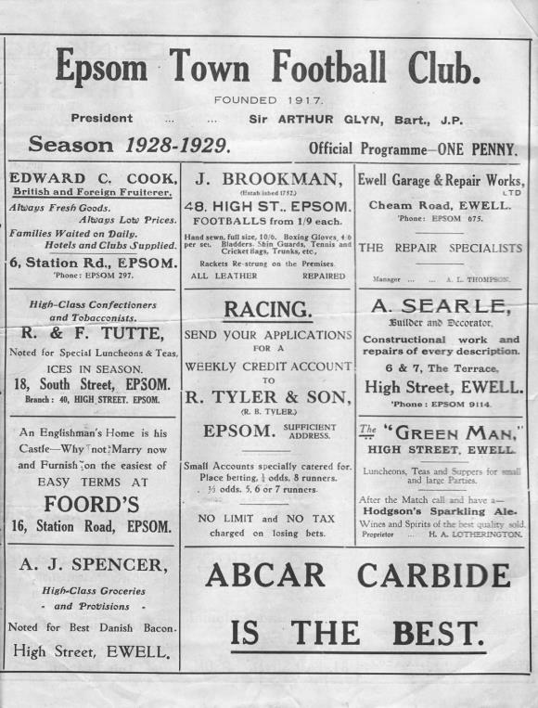
90 years ago this week The famous Isthmian League side Casuals visited West Street for a Surrey Senior Cup Quarter-Final (see programme left) and led at half time, but two second half goals from George Carmichael and another from Freddie Behn gave us a 3-1 win and a Semi-Final against another powerful Isthmian League side in Wimbledon whom we would ultimately beat too!

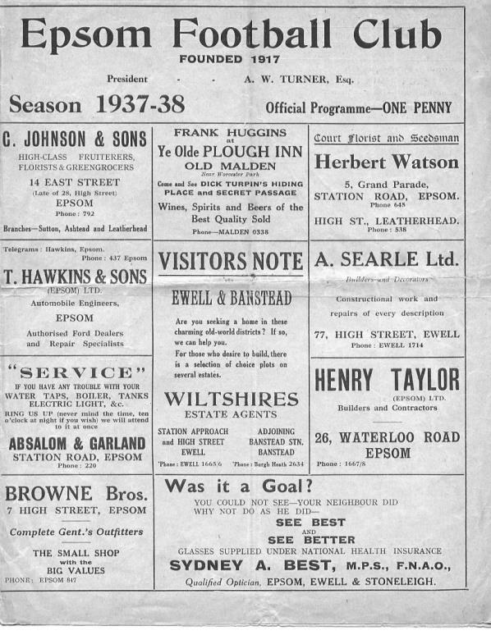
71 years ago today we had another Surrey Senior Cup Quarter-Final against another Isthmian League team in Nunhead who we absolutely crushed 5-1 at West Street with goals from Tommy Rochester (2), Brian Beglan, Jimmy Jones and Geoff Collins. The Semi-Final would end in defeat after a replay to Dulwich Hamlet but we were definitely mixing it with the big boys throughout the whole of the thirties. (see programme right)

25 years ago today a hat trick from Paul Meredith enabled us to secure a 4-2 win at East Thurrock United in a League match. We had an excellent record over there, even doing the double over them the following season when they went up as Champions. Meredith, who was also a former Youth team player at Epsom, is now a diving instructor in Thailand!

Godalming Town – History
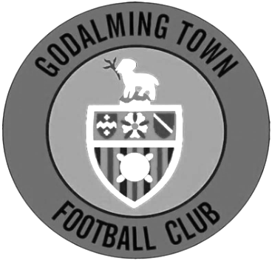
The club has its origins as Godalming United FC, formed in 1950 by ex-pupils of Godalming Grammar School.

Between 1950-71 the club played at the Recreation Ground. However, in 1970 Surrey Senior League side Farncombe collapsed, leaving their ground in Meadrow vacant. Godalming took over the debts and tenancy, changing their name to Godalming and Farncombe FC, and the ground to Wey Court in the process.

The original pitch was where the nearby Wey Court Sheltered Housing stood and considerable amount of work was undertaken on the new playing area, which was built on the site of an old waste tip. The club was helped by Waverley Council when drainage problems and subsidence meant they had to find a temporary home at Broadwater Park.

The club was accepted into the Combined Counties League for the start of the 1978 season, and a year later the name was changed again, to Godalming Town FC.

In 1985, another local club, Addlestone & Weybridge, was disbanded and, before their ground at Liberty Lane was demolished, Godalming purchased the stand and perimeter fence for £225 and £50 respectively. The stand was re-erected at Wey Court, with seating and fascia added.

The next development came in 1992 when the Guildford Football Appeal (formed in an attempt to return the towns name to senior football, following the collapse of Guildford City in 1977) donated a sum of money towards floodlights, and in return the name of the club was changed again to Godalming & Guildford FC.

Further recycling followed in 1995, when a new turnstile building was erected incorporating a turnstile from Millwall’s old ground and in 1996 the clubhouse was refurbished.

During 2005 close season, the club changed its name for a fifth time, albeit back to one of its previous incarnations, that of Godalming Town. A fantastic 2005/06 season saw the side take the Combined Counties League Championship and League Cup by storm. Godalming Town were then accepted by Isthmian League officials following extensive ground improvements.

At the end of a tough season, Godalming found themselves at the bottom of a very competitive division. However, events elsewhere meant that Godalming were reprieved from relegation and were transferred into the Southern League’s South & West Division for the 2007/08 season. Chuck Martini replaced Roger Steer as Manager in October 2007. Town were moved back to the Ryman League for the 2008/09 season and eventually finished in another record high position, 9th. Godalming also progressed further than ever before in the FA Cup by reaching the 3rd Qualifying Round before losing 2-1 at Conference South side Havant & Waterlooville.

The 2009/10 season was arguably the best season in the history of the club. Town finished a record high position 4th in the Ryman South but were eventually beaten 2-1 in the Playoff Final at Folkestone Invicta. The club progressed further than ever before in the FA Trophy and won the Surrey Senior Cup by beating Sutton United 2-1. The season also saw local boy Shaun Elliott became the club’s record appearance holder after reaching 360 games in a

Godalming shirt. Chuck Martini was replaced by joint-managers Jon Underwood & Neil Baker in October 2010 and the club finished an unpredictable season in mid-table. The 2011/12 season saw a lot of new faces join, but the team quickly gelled, reaching the 4th Qualifying Round of the FA Cup, beating Wimborne, Moneyfields, Worcester City & Bodmin before bowing out to Maidenhead United in front of 700 at Wey Court. The G’s finished 5th in the league, and travelled to Bognor Regis Town in the playoff semi-final, drawing 4-4 after extra time but Godalming lost 5-3 on penalties.

2012/13 saw Jon Underwood and Neil Baker guide Godalming to their highest ever finish in the pyramid, finishing in 3rd place. The G’s lost in the playoff semi-final for the second year running, this time losing 2-1 to Biggleswade at Wey Court. The season finished on a high however, as Godalming lifted the Surrey Senior Cup for the second time in four years, beating Sutton United 1-0 at Gander Green Lane, thanks to a last minute goal from Scott Harris. The close season saw Godalming moved to a third different league in as many years, this time to the South & West Division. With divisional change came a managerial change; Jon Underwood and Neil Baker left Godalming to join Slough Town, taking the majority of the squad with them. Andy Hunt was appointed manager in June 2013, assisted by Neil Selby.

The 2013/14 season was probably one of the hardest the club has dealt with. Andy Hunt was given the task of putting together a squad that will compete in the league and secure step four football. At Christmas 2013 the clubhouse, kitchen and changing rooms were ruined by flood water. Godalming finished the season in 18th position. Godalming were then moved into another division again and will play in Southern League Central Division for the 2014/15 season.

Godalming finished in 10th position in the 2015/2016 and reached the Surrey Senior Cup Final for the 3rd time but lost 4-0 to Merstham.

The 2016/2017 season could be viewed as an annus horibilis for the men as wins became less frequent than management changes. Andy Hunt left and was replaced by Dean Thomas who subsequently departed before the club was relegated under Dan Turkington. Inevitably relegation followed and Dan departed, as did much of the entire first team.

On the upside the Ladies team under the auspices of Steve Davies and , Darren Wheeler finished second in Division 2 South and were promoted to division one in the Greater London Womens Football League.

2017/18 began in familiar fashion with a new management and a new squad in a new division. After a promising start under Simon Funnell and Matt Drew (including a brief run in the FA Cup which finally ended at Hereford), wins became harder to come by and by Christmas, Jon Palmer and Gavin Smith were in charge. After a slow start, a promising run took the G’s out of the relegation zone before fixture congestion and a high turnover of players led to a second relegation in two years.

The Ladies first team continued to go from strength to strength with an exciting FA Cup run and promotion to the GLWFL Premiership. The Ladies development team finished an excellent 3rd in division 3 which meant they were promoted also in the division two south for the 2018/19 season.

Godalming Town first team will compete in the Combined Counties League Division One for the 2018/19 season.

Centre page for results

Centre page for results

First Eleven Appearances 2018/19 - (max 34)
Name | Debut | 2018/19 |  |  |  | Career Totals
 |  | App | Sub | Tot | Goals | App | Sub | Tot | Goals
BENNETT Bobby | 12/08/2018 | 28 | 0 | 28 | 19 | 28 | 0 | 28 | 19
BETANCOURT Steve* | 18/08/2018 | 21 | 1 | 22 | 1 | 21 | 1 | 22 | 1
BORRETT Ricky* | 04/08/2018 | 9 | 0 | 9 | 0 | 9 | 0 | 9 | 0
CAMPBELL Kieran* | 29/09/2012 | 7 | 3 | 10 | 2 | 59 | 3 | 62 | 2
CAMPBELL Theo* | 28/08/2018 | 2 | 9 | 11 | 1 | 2 | 9 | 11 | 1
CARNEY Billy | 12/01/2019 | 3 | 1 | 4 | 3 | 3 | 1 | 4 | 3
CAULCRICK Joshua | 17/02/2018 | 0 | 4 | 4 | 0 | 0 | 5 | 5 | 0
CHICK Ben | 29/12/2018 | 2 | 4 | 6 | 2 | 2 | 4 | 6 | 2
CHIN Louis | 08/12/2018 | 6 | 0 | 6 | 0 | 6 | 0 | 6 | 0
CONNELLY Lloyd | 14/10/2017 | 33 | 0 | 33 | 4 | 63 | 4 | 67 | 6
DOBRAJ Endrit* | 18/11/2017 | 5 | 2 | 7 | 1 | 24 | 6 | 30 | 1
DYSON Ben* | 12/08/2017 | 0 | 1 | 1 | 0 | 28 | 14 | 42 | 2
ELGAR Luke | 04/08/2018 | 12 | 3 | 15 | 2 | 12 | 3 | 15 | 2
ELGAR Scott* | 12/08/2018 | 4 | 9 | 13 | 0 | 4 | 9 | 13 | 0
GAFFNEY Luke * | 16/08/2014 | 2 | 2 | 4 | 0 | 12 | 3 | 15 | 0
GAYLE Roy | 06/11/2018 | 3 | 3 | 6 | 0 | 3 | 3 | 6 | 0
GILL George* | 28/08/2018 | 2 | 0 | 2 | 0 | 2 | 0 | 2 | 0
GRIFFIN Reisse | 08/08/2015 | 19 | 0 | 19 | 3 | 123 | 13 | 136 | 11
GRIFFITHS Hakim | 08/12/2018 | 2 | 2 | 4 | 1 | 2 | 2 | 4 | 1
HEAGNEY Adam | 16/08/2016 | 33 | 0 | 33 | 1 | 100 | 13 | 113 | 3
HENDRY Rob | 08/08/2015 | 18 | 0 | 18 | 15 | 102 | 23 | 125 | 43
JEANNOEL Germaine | 02/12/2017 | 1 | 10 | 11 | 2 | 3 | 17 | 20 | 3
JONES David* | 31/08/2018 | 6 | 2 | 8 | 0 | 6 | 2 | 8 | 0
LOFTUS-CHEEK Joe* | 06/08/2017 | 0 | 1 | 1 | 0 | 14 | 8 | 22 | 6
MARTINEZ Olly | 29/09/2018 | 8 | 3 | 11 | 2 | 8 | 3 | 11 | 2
MCKAY Alex | 20/12/2008 | 1 | 0 | 1 | 0 | 163 | 39 | 202 | 13
MORGAN Sam | 11/09/2018 | 2 | 6 | 8 | 0 | 2 | 6 | 8 | 0
MURPHY Scott | 20/01/2007 | 29 | 0 | 29 | 3 | 76 | 2 | 78 | 7
MURPHY Todd | 27/11/2018 | 1 | 3 | 4 | 0 | 1 | 3 | 4 | 0
ROBERTS Liam | 12/08/2017 | 23 | 2 | 25 | 11 | 44 | 16 | 60 | 16
SMITH Taryn | 28/10/2017 | 6 | 6 | 12 | 5 | 14 | 10 | 24 | 5
SULLIVAN Ryan | 04/08/2018 | 22 | 1 | 23 | 0 | 22 | 1 | 23 | 0
SUTHERLAND Mitchel* | 04/08/2018 | 1 | 1 | 2 | 0 | 1 | 1 | 2 | 0
THOMPSON Elliott | 09/02/2016 | 22 | 4 | 26 | 1 | 32 | 13 | 45 | 2
WATTS Jamie | 03/11/2018 | 6 | 1 | 7 | 1 | 6 | 1 | 7 | 1
WHITE Sean* | 02/08/2014 | 9 | 4 | 13 | 4 | 29 | 25 | 54 | 9
WOODCOCK Josh* | 22/09/2018 | 1 | 0 | 1 | 0 | 1 | 0 | 1 | 0
WRIGHT Kieran* | 15/09/2018 | 3 | 3 | 6 | 0 | 3 | 3 | 6 | 0
YOUNG Conor | 07/03/2015 | 22 | 0 | 22 | 0 | 55 | 0 | 55 | 0
* - Player has left the club

Previous Managers
In our latest instalment we reach the pinnacle of our story!

Adrian Hill – March 1982 – May 1985
Alan Webb – May 1985 – Sept 1986

How do you follow Pat O’Connell?

This was the question most fans were asking as the home match with Hornchurch on Saturday 6th March was postponed (although we received a token fine of £50 from the Isthmian League for our trouble) so that we could have a supporters meeting at the clubhouse which was Chaired by Peter Smith, our Chairman.

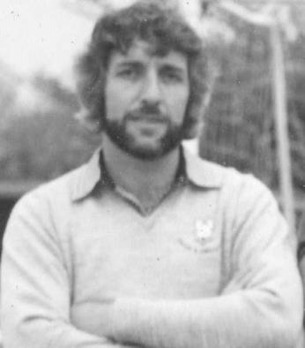
What Smith maybe didn’t realise at the time was how successful O’Connell’s replacement would prove to be. Adrian Hill, born in Ruislip on 15th April 1945 was a central defender with much experience at Croydon, Redhill, Leatherhead and latterly Epsom & Ewell had left our club in 1980 to become Player / Manager at Dorking. He jumped at the chance to Manage at the higher level and brought keeper Steve Chapman and Physio Dennis Kenny with him. Chapman was best known for playing in goal for Charlton Athletic, while Ada as he was affectionately known was a refrigeration engineer.

Inevitably Hill had to move quickly to bring in new players from almost anywhere. To his credit, he didn’t raid the Dorking club, but picked up players from many different teams. Four came from Whyteleafe, one of whom, Alan Pardew, would play four times for us before eventually ending up in the Football League where he would also go on to be Manager at many clubs.

The first match after the O’Connell walkout was a 2-0 home defeat against Hampton, but the second on Saturday 13th March 1982 resulted in a 1-0 win over Aveley with a Kelvin Roots penalty securing the points at West Street.

We managed to survive fairly comfortably that season, although 1982/83 was a little more concerning. We were close to the relegation positions for a while but a 5-0 win over bottom club St Albans City coupled with the news that only one team would go down, lightened the mood just before Christmas and five consecutive goalless draws in January and February, which weren’t exciting but did provide five points, helped us inch to safety. In fact, the defensive run continued for a while and Steve Chapman set two club records in the process; one of ten hours 50 minutes without conceding a goal in any match and one of ten hours 33 minutes without conceding at West Street; a run which would not end until April!

Survival was not an issue in the end and we hit the ground running in 1983/84 with a goal after 27 seconds of our opening match against Boreham Wood in an eventual 2-1 win. We remained amongst the top sides all season, although never touched the top spot. Then in March 1984 we lost at home for the first time in a League match for fifteen months. We had gone the whole of 1983 unbeaten at home in the League!

We bounced back immediately though and finished strongly, with players of the calibre of Paul Harding, Steve Milton and Murray Jones in our line-up who would all go on to play in the Football League, added to the free scoring Steve Hill, who notched 38 goals and a solid defence, we finished as runners-up to Champions Windsor & Eton on a memorable night on 1st May 1984 when we won 2-1 at Farnborough Town and had the added bonus of a Surrey Senior Cup Final appearance, losing to Premier Division Sutton United at Imber Court.

Finally, we had reached the Isthmian League Premier Division! Pat O’Connell had aimed to do it in ten years and ultimately it took the club eleven, but no one was counting! We strengthened for the new season with the return of former scoring legend Tommy Tuite and his partnership with Hill would be record breaking and remains the greatest we have had at the club, despite the recent claims of Robbie Burns and Kyle Hough.

We started off slowly with an opening day defeat to a good Hayes team and the winless run extended until November with narrow defeats all over the place, including a fluky 4-3 loss at Worthing and another similar match that was lost 5-4 at Sutton on consecutive September Tuesdays. A 3-0 win over Hitchin on 3rd November got us up and running and three days later we destroyed Leytonstone & Ilford 5-1 on their own ground. Hill and Tuite would score 67 goals between them with Tuite getting 34 to Hill’s 33 and we survived in a very comfortable 13th place.

However, Hill had decided he could go as far as he could at the club and resigned to take the job at another of his old clubs, Croydon. Much of the team went with him as they would achieve a fourth place finish in the Premier Division during 1985/86, although Tuite would remain and the baton was passed very easily by the Committee to our successful Reserve Team Manager and long serving player Alan Webb. There will be more about Ada in future editions!

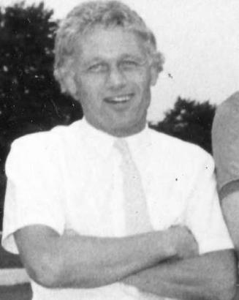
Webb was born on 14th July 1947 in Fulham and had joined us from Tooting & Mitcham United in 1972, becoming the only player at the club to play in the Wembley F.A. Vase Final who had pre-dated O’Connell at the club, with exception of Johnny Eales. He went on to make 352 appearances for the club, which placed him seventh on the all-time list at the time of his final match and he still sits eighth even now with many more matches played these days. He had taken the Reserves to Second place in the Suburban League and was a popular choice.

However, he had to build almost a new team from scratch with not a great deal of money. This was a tough ask, and whilst some players remained like Chris Hills, Dave Hanks and Robin Lewis, all former Youth team players at the club, we were to rely on a number of unproven names. Five players made their debuts at Walthamstow Avenue on 24th August 1985 as we led 2-0 but failed to hold on and had to settle for a 2-2 draw. An own goal gave us the points against Bognor Regis Town the following Tuesday in a match which contained an appearance from former Professional Trevor Lee and then we had the Hendon rollercoaster as we trailed 3-0 at West Street but reduced the gap to 2-3 by the half and went on to win 5-3.

Yeovil Town were the only side above us as we sat in second place in the entire Isthmian League and their defeat at Croydon on the Monday gave us a chance to go top if we could defeat Dulwich Hamlet on Tuesday 3rd September. However, the Hamlet won 3-0 and things went steadily worse as we slipped down the table, eventually finding ourselves bottom where a 4-2 home defeat to Wokingham Town on the final day of the season sealed our fate, despite the addition to the playing ranks of former Sutton United and Dagenham legend Ricky Kidd in October of 1985.

Webb was retained for the 1986/87 season but lasted just five matches before being sacked as Sussex League Three Bridges knocked us out of the F.A. Cup and he was replaced by Kidd. Webb was quoted as saying he felt he had been stabbed in the back, but I also heard that the club were concerned he had gone on holiday to America at a time when it was crucial to recruit new players. Webb remains at number 1 on my list for former Epsom people I would like to talk to, mainly to get his version of events here as much as for his other exploits!

How we stand – Locally and Nationally – inc Sat 09/02/19
Here is the latest update on where we all stand.

To summarise for new readers, there are 28 promotion places currently available at Step Six, with 358 teams battling away for those spots. The Champions of each League are guaranteed a promotion, with the best nine runners-up also going up. This number looks as though it will rise by four due to no likely promotions from the South West Peninsula League and the now confirmed folding of Isthmian League Thamesmead Town and voluntary demotion of Aylesbury FC, but this could increase further. For now we’ll continue to look at the 28 and anything else will be a bonus!

In our previous review, we were listed as 69th Nationally. Since that update we have played no league games but have moved up to 68th place.

Below is our current League table sorted by points per game, while across the page we have the overall top ten and most importantly the 28 clubs who would go up if the season ended right now.

Frimley Green, currently holding the runners-up spot in our League on points per game have the 15th best record of the 19 second placed teams. Our league is so competitive right now that it may well prove to be just the Champions that go up, but I’ll keep updating the position here while we remain involved.

Combined Counties League Division One Table – by PPG
 | Pld | W | D | L | Pts | GD | PPG | Pos
Bedfont & Feltham | 23 | 16 | 5 | 2 | 53 | +52 | 2.30 | 1
Frimley Green | 24 | 16 | 5 | 3 | 53 | +21 | 2.21 | 2
Sheerwater | 24 | 16 | 4 | 4 | 52 | +31 | 2.17 | 3
Farnham Town | 21 | 13 | 4 | 4 | 43 | +27 | 2.05 | 5
Epsom & Ewell | 24 | 15 | 3 | 6 | 48 | +24 | 2.00 | 4
Tooting Bec | 22 | 12 | 5 | 5 | 41 | +23 | 1.86 | 6
Sandhurst Town | 21 | 11 | 3 | 7 | 36 | -2 | 1.71 | 9
Ash United | 25 | 12 | 5 | 8 | 41 | +12 | 1.64 | 7
Dorking Wanderers Res | 27 | 11 | 4 | 12 | 37 | -5 | 1.37 | 8
Chessington & Hook Utd | 22 | 8 | 5 | 9 | 29 | -3 | 1.32 | 11
British Airways | 24 | 9 | 4 | 11 | 31 | -9 | 1.29 | 10
Godalming Town | 24 | 8 | 3 | 13 | 27 | -19 | 1.13 | 13
Bagshot | 27 | 8 | 4 | 15 | 28 | -43 | 1.04 | 12
FC Deportivo Galicia | 23 | 6 | 3 | 14 | 21 | -6 | 0.91 | 14
Eversley & California | 22 | 5 | 2 | 15 | 17 | -16 | 0.77 | 15
Kensington Borough | 23 | 3 | 6 | 14 | 15 | -32 | 0.65 | 18
Cove | 24 | 4 | 3 | 17 | 15 | -23 | 0.63 | 16
Fleet Spurs | 24 | 5 | 0 | 19 | 15 | -32 | 0.63 | 17

Step Six Table – by PPG – Top 10
 | Which League? | Pld | Pts | GD | PPG | Current Pos.
Harefield United | SSML | 24 | 68 | 59 | 2.83 | 1
Tavistock | SWP | 24 | 62 | 48 | 2.58 | 1
Racing Club Warwick | Midland | 23 | 59 | 54 | 2.57 | 3
Cheltenham Saracens | HellW | 13 | 33 | 45 | 2.54 | 1
Anstey Nomads | UCL | 25 | 63 | 70 | 2.52 | 1
Selston | E.Mids | 25 | 63 | 55 | 2.52 | 2
Cheddar | Western | 24 | 60 | 47 | 2.50 | 1
Amesbury Town | Wess | 24 | 60 | 43 | 2.50 | 1
Easington Sports | HellW | 12 | 30 | 39 | 2.50 | 2
Heather St Johns | Midland | 25 | 62 | 70 | 2.48 | 1
Epsom & Ewell | We are 68th | 24 | 48 | +24 | 2.00 | 4

Step Six Table – The 28 Promoted Clubs if the season ended today
The 19 Champions – Based on current PPG
 | Which League? | Pld | Pts | GD | PPG | Current Pos.
Harefield United | SSML | 24 | 68 | 59 | 2.83 | 1
Tavistock | SWP | 24 | 62 | 48 | 2.58 | 1
Racing Club Warwick | Midland | 23 | 59 | 54 | 2.57 | 3
Cheltenham Saracens | HellW | 13 | 33 | 45 | 2.54 | 1
Anstey Nomads | UCL | 25 | 63 | 70 | 2.52 | 1
Selston | E.Mids | 25 | 63 | 55 | 2.52 | 2
Cheddar | Western | 24 | 60 | 47 | 2.50 | 1
Amesbury Town | Wess | 24 | 60 | 43 | 2.50 | 1
Longridge Town | NWCN | 28 | 69 | 71 | 2.46 | 1
Billingham Town | Northern | 28 | 69 | 52 | 2.46 | 1
Steyning Town | Scomb | 22 | 54 | 36 | 2.45 | 2
Tividale | W.Mids | 29 | 71 | 80 | 2.45 | 1
Burnham | HellE | 17 | 41 | 39 | 2.41 | 1
Bedfont & Feltham | CCL | 23 | 53 | 52 | 2.30 | 1
Harleston Town | EastN | 27 | 62 | 50 | 2.30 | 1
Hashtag United | EastS | 28 | 64 | 40 | 2.29 | 1
Erith & Belvedere | SCEFL | 19 | 43 | 35 | 2.26 | 5
Campion | NCEL | 24 | 54 | 30 | 2.25 | 2
Rylands | NWCS | 27 | 60 | 60 | 2.22 | 1
And the 9 best Runners-Up currently
Easington Sports | HellW | 12 | 30 | 39 | 2.50 | 2
Heather St Johns | Midland | 25 | 62 | 70 | 2.48 | 1
AFC Stoneham | Wess | 22 | 54 | 55 | 2.45 | 4
Newark Flowserve | E.Mids | 26 | 63 | 72 | 2.42 | 1
Avro | NWCN | 25 | 60 | 48 | 2.40 | 2
Alfold | Scomb | 23 | 55 | 40 | 2.39 | 1
Lutterworth Town | UCL | 24 | 57 | 73 | 2.38 | 2
Keynsham Town | Western | 25 | 59 | 48 | 2.36 | 2
Exmouth Town | SWP | 26 | 61 | 47 | 2.35 | 2

Player Sponsorship
Here is the latest list for 2018/19, with new photos showing all of our players and Management that are available for sponsorship.

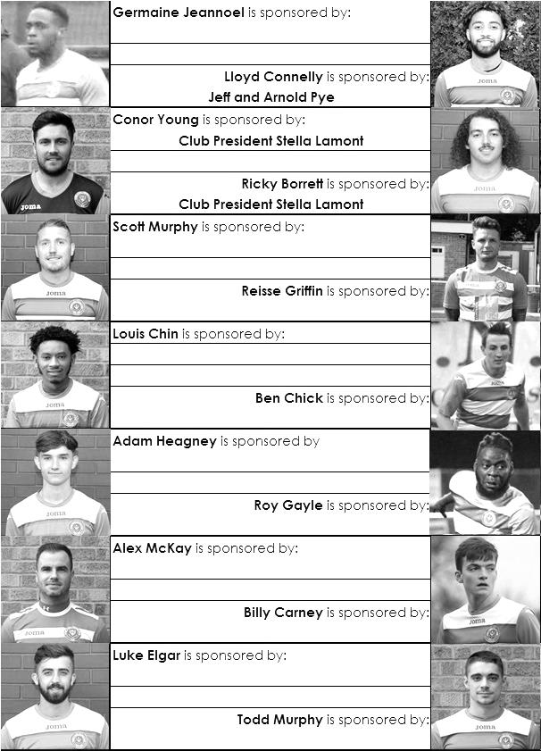

Sponsorship costs just £40 and it is easy to do. Just select a player who has not been previously sponsored and let a Committee Member know that you would like to sponsor them. Beware though. Until we have received the money it is possible for someone to jump in front of you, so don’t delay, sponsor today!

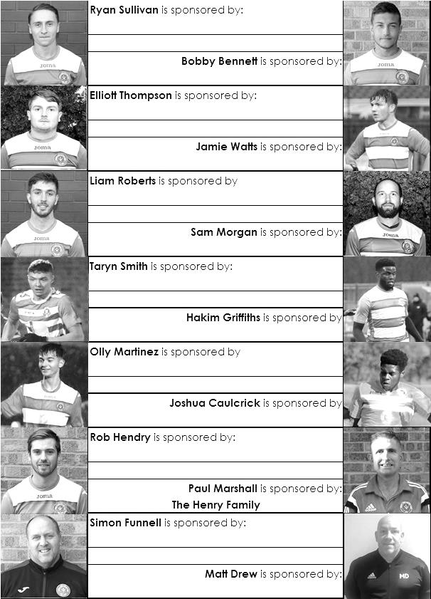

EL Records Premier Challenge Cup
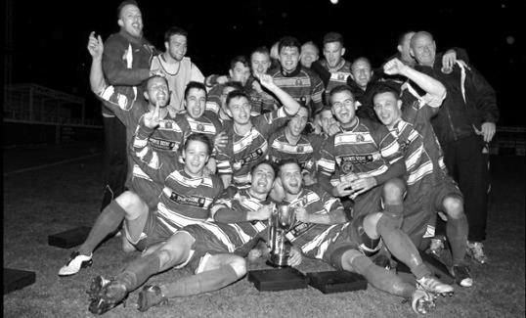
Second Round
Bedfont & Feltham | 2-0 | Tooting Bec
Sheerwater | 1-0 | Balham
Ash United | 2-3 | Fleet Spurs
Frimley Green | 0-2 | Guildford City
Godalming Town | 2-0 | Dorking Wanderers Reserves
Abbey Rangers | 3-0 | Redhill
FC Deportivo Galicia | 5-0 | AC London
Cobham | 0-3 | AFC Hayes
Abandoned after 88 minutes due to serious player injury - Match awarded to AFC Hayes
CB Hounslow United | 4-1 | Badshot Lea
Hanworth Villa | 2-1 | Sandhurst Town
Epsom & Ewell | 1-0 | Bagshot
Sutton Common Rovers | 4-2 | Southall
Chertsey Town | 3-2 | British Airways
Eversley & California | 1-5 | Knaphill
Banstead Athletic | 4-3 | Colliers Wood United
Spelthorne Sports | 2-1 | Raynes Park Vale
Third Round
FC Deportivo Galicia | 0-2 | Sutton Common Rovers
AFC Hayes | 0-1 | Bedfont & Feltham
Epsom & Ewell | 12/2 | Godalming Town
Sheerwater | 0-3 | Banstead Athletic
Guildford City | 0-2 | CB Hounslow United
Spelthorne Sports | 0-1 | Hanworth Villa
Knaphill | 3-1 | Fleet Spurs
Chertsey Town | 1-2 | Abbey Rangers
Quarter Finals
Abbey Rangers | V | Epsom & Ewell/Godalming Town
Knaphill | V | Bedfont & Feltham
Sutton Common Rovers | V | Hanworth Villa
CB Hounslow United | V | Banstead Athletic

Esoteric League Division One Challenge Cup
First Round
Farnham Town | 0-1 | Godalming Town
Cove | 2-1 | British Airways
FC Deportivo Galicia | 2-1 | AC London
Second Round
Eversley & California | 2-3 | Bedfont & Feltham
Epsom & Ewell | 1-0 | Sandhurst Town
Tooting Bec | 4-1 | Ash United
Kensington Borough | 0-2 | FC Deportivo Galicia
Sheerwater | 2-3 | Chessington & Hook United
Fleet Spurs | 0-0 - 4-3p | Cove
Dorking Wanderers | 1-2 | Frimley Green
Godalming Town | 6-0 | Bagshot
Quarter-Finals
Tooting Bec | 5/3 | Frimley Green
Bedfont & Feltham | 1-2 | Epsom & Ewell
FC Deportivo Galicia | 5-1 | Godalming Town
Fleet Spurs | 0-0 – 4-3p | Chessington & Hook United

Surrey Premier Cup
First Round
Carshalton Athletic U19 | w/o Ash | Ash United
Shene Old Grammarians | 2-4 | Old Wilsonians
Lingfield | 5-1 | Horley Town Reserves
Alfold | 2-0 | Godalming Town
Epsom & Ewell | 5-0 | Knaphill U23
Reigatians | 0-4 | Frimley Green
Met Police Reserves | 3-3 - 5-4p | FC Deportivo Galicia
Second Round
Ash United | 3-1 | Chessington & Hook United
Alfold | 0-1 | Nottsborough (holders)
Old Wilsonians | 1-6 | Lingfield
Sheerwater | 5-0 | Corinthian Casuals Reserves
Farnham Town | 4-1 | Westfield Reserves
Epsom & Ewell | 4-0 | Dorkinian
Met Police Reserves | 7-3 | Dorking Wanderers Reserves
Bagshot | 1-3 | Frimley Green
Quarter-Finals
Ash United | 1-3 | Frimley Green
Met Police Reserves | 20/2 | Epsom & Ewell
Farnham Town | 19/2 | Lingfield
Nottsborough (holders) | 16/2 | Sheerwater

Match and Ball Sponsorships – 2018/19
Opponent | Date | Match Sponsor | Ball Sponsor
Chessington & Hook Utd | 21/08/18 | Club President - Stella Lamont
Beckenham Town (FAC) | 28/08/18 | Building Shop Ltd
Cove | 08/09/18 | EEFC Management Committee
Tooting Bec | 15/09/18 | Building Shop Ltd
Bagshot (LC) | 25/09/18
Sheerwater | 06/10/18 | Paul Merritt
Knaphill U23  (Surrey Premier Cup) | 23/10/18 | Jack Jarman
Frimley Green | 03/11/18 | Our Chairman’s Grandchildren – George, Joseph, Ezara and Inaya
Sandhurst Town (LD1C) | 06/11/18 | Richard Lambert
Kensington Borough | 17/11/18 | Jeff & Arnold Pye
Dorkinian (SPC) | 20/11/18
Dorking Wanderers Res | 27/11/18
Godalming Town | 01/12/18 | John Bonner
Bedfont & Feltham | 08/12/18
Eversley & California | 29/12/18
Ash United | 12/01/19 | Gary and Gemma Jarman
Bagshot | 19/01/19 | Steve and Geoff Dyke
Godalming Town (LC) | 12/02/19
British Airways | 16/02/19
FC Deportivo Galicia | 12/03/19
Fleet Spurs | 06/04/19
Sandhurst Town | 20/04/19 | Club President - Stella Lamont
Farnham Town | 27/04/19 | In memory of Chris Henry R.I.P.
Match sponsorship costs just £60.00!

Sponsorship includes:

Admission, programmes and hospitality for three people.

A full page advert in the programme and mascot for the day (if required).

If you are interested, just speak to a Committee Member,
or drop me an email at: richard.c.lambert@gmail.com

Combined Counties League Premier Division
Opponents All-time Records
incl Saturday  9th February | P | W | D | L | F | A | PPG | GD | Best  Win | Worst  Loss
Bagshot | 3 | 3 | 0 | 0 | 11 | 1 | 3.00 | +10 | 7-1 | -
AC London | 1 | 1 | 0 | 0 | 6 | 0 | 3.00 | +6 | 6-0 | -
FC Deportivo Galicia | 1 | 1 | 0 | 0 | 3 | 0 | 3.00 | +3 | 3-0 | -
Tooting Bec | 1 | 1 | 0 | 0 | 3 | 1 | 3.00 | +2 | 3-1 | -
Fleet Spurs | 1 | 1 | 0 | 0 | 3 | 2 | 3.00 | +1 | 3-2 | -
Frimley Green | 11 | 9 | 1 | 1 | 35 | 5 | 2.55 | +30 | 7-1 | 0-1
Bedfont & Feltham | 4 | 3 | 1 | 0 | 19 | 8 | 2.50 | +11 | 9-2 | -
Godalming Town | 5 | 4 | 0 | 1 | 10 | 8 | 2.40 | +2 | 3-1 | 0-3
Ash United | 21 | 11 | 4 | 6 | 50 | 32 | 1.76 | +18 | 6-0 | 0-3
Farnham Town | 18 | 9 | 4 | 5 | 31 | 29 | 1.72 | +2 | 3-0 | 1-4
Cove | 36 | 17 | 9 | 10 | 80 | 58 | 1.67 | +22 | 7-0 | 1-6
Chessington & Hook | 30 | 13 | 9 | 8 | 63 | 45 | 1.60 | +18 | 6-0 | 1-3
Sheerwater | 5 | 2 | 2 | 1 | 10 | 5 | 1.60 | +5 | 3-0 | 2-3
Dorking Wanderers Res | 2 | 1 | 0 | 1 | 6 | 5 | 1.50 | +1 | 3-0 | 3-5
Eversley & California | 2 | 1 | 0 | 1 | 2 | 2 | 1.50 | 0 | 1-0 | 1-2
Sandhurst Town | 16 | 7 | 0 | 9 | 28 | 28 | 1.31 | 0 | 4-0 | 1-3
Kensington Borough | 1 | 0 | 1 | 0 | 1 | 1 | 1.00 | 0 | - | -
British Airways | 1 | 0 | 0 | 1 | 2 | 3 | 0.00 | -1 | - | 2-3

Combined Counties League Cup – Third Round
Tuesday, 12th February 2019 - Kick-off 7.45 p.m.
Epsom and Ewell  (Royal Blue & White hoops) | V |  | Godalming Town  (Yellow / Green / Yellow )
Squad | NUMBERS |  | Squad
Conor Young |  |  | Jordan Knight
Louis Chin |  |  | Taylor Davies
Luke Elgar |  |  | Jordan Bird ©
Reisse Griffin |  |  | Jack Howard
Lloyd Connelly |  |  | Curtis Osano
Jamie Watts |  |  | Levi Crew
Adam Heagney |  |  | Craig Adu-Adeji
Sam Morgan |  |  | Chris Burke
Todd Murphy |  |  | Ashley Wright
Ryan Sullivan |  |  | Darren Wheeler
Liam Roberts |  |  | Jack Cleevely
© Scott Murphy |  |  | Dom Hardisty
Elliott Thompson |  |  | Abdullah Asiamah
Bobby Bennett |  |  | Frankie Ryan-Maynard
Rob Hendry |  |  | Anthony Myers
Roy Gayle |  |  | Reece Weekes
Olly Martinez
Germaine Jeannoel
Hakim Griffiths
Joshua Caulcrick
Ben Chick
Billy Carney
Simon Funnell | MANAGER |  | Les Cleevely
Matt Drew / Paul Marshall | ASSISTED BY |  | Jordan Knight
Matt Drew | COACHES |  | Jason Kerbey
Chantelle Farrell | PHYSIO |  | Rebecca Peacock
REFEREE: D.Lunani
ASSISTANTS: S.Idris, D.Johnston

OUR NEXT VISITORS TO HIGH ROAD
British Airways
Combined Counties League – Division One
Saturday, 16th February 2019 – 3.00 pm

